**Chapter 10 - Two Mothers Remembered**

**All Lectures Uploaded on YouTube:** [**https://tinyurl.com/fkm9-english**](https://tinyurl.com/fkm9-english)

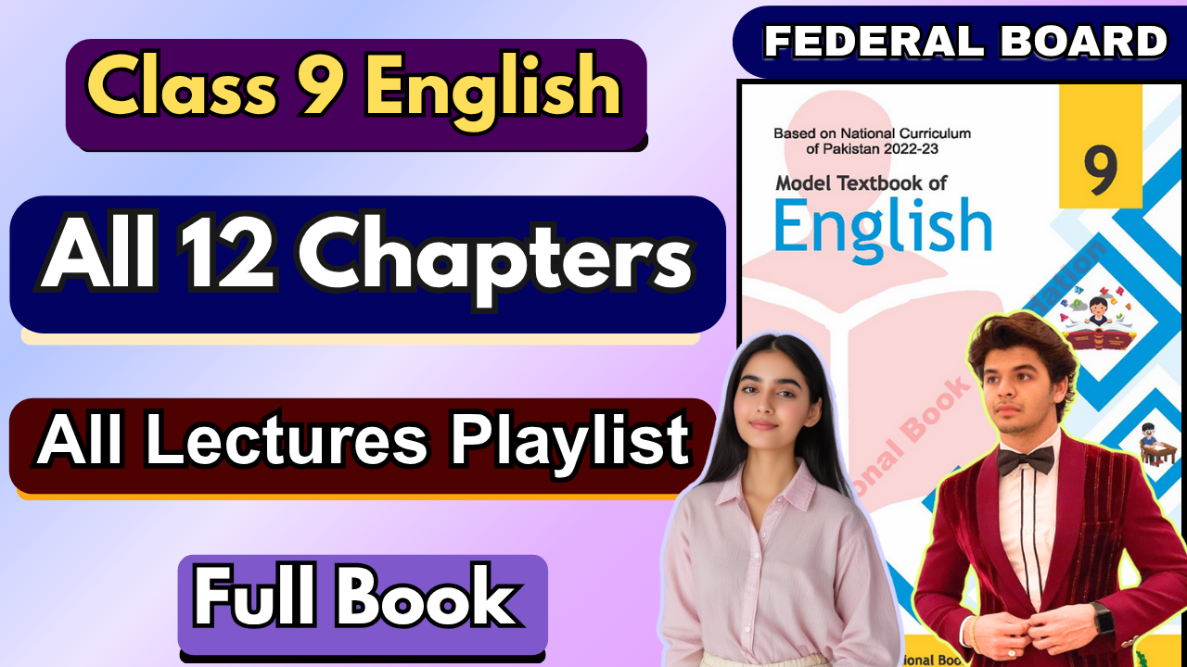

# 

**Glossary:**

**Given below are the difficult words from the unit. Look at their meanings and use these words in your own sentences.**

| **Words** | **Meaning** |
| --- | --- |
| diverse | different, varied |
| nurtured | raised, brought up |
| launched | started, tossed |
| cloud | troubled, disturbed |
| at arm’s length | at a distance |

The following are the sentences for the above mentioned words:



**Diverse** – Our class is very **diverse**, with students from different cultures, languages, and backgrounds.

**Nurtured** – The young artist **nurtured** her talent by practicing every single day.

**Launched** – The company **launched** a new smartphone that quickly became popular worldwide.

**Cloud** – A dark **cloud** slowly moved across the sky, warning everyone that rain was coming.

**At arm’s length** – She kept the angry dog **at arm’s length** until its owner arrived.

**Reading and Critical Thinking Skills**

**A. Reading Comprehension Questions:**

# How are the two mothers different from each other?

**Ans.** The first mother was the speaker's biological mother, who raised, nurtured, and guided her. She was strong and caring. The second mother, however, was the same woman in old age, when she became weak, dependent, and childlike due to aging and memory loss.

# What are the similarities between both?

**Ans.** Both mothers were the same person—the speaker's real mother at different stages of life. They shared the same name and appearance, and both loved the speaker deeply.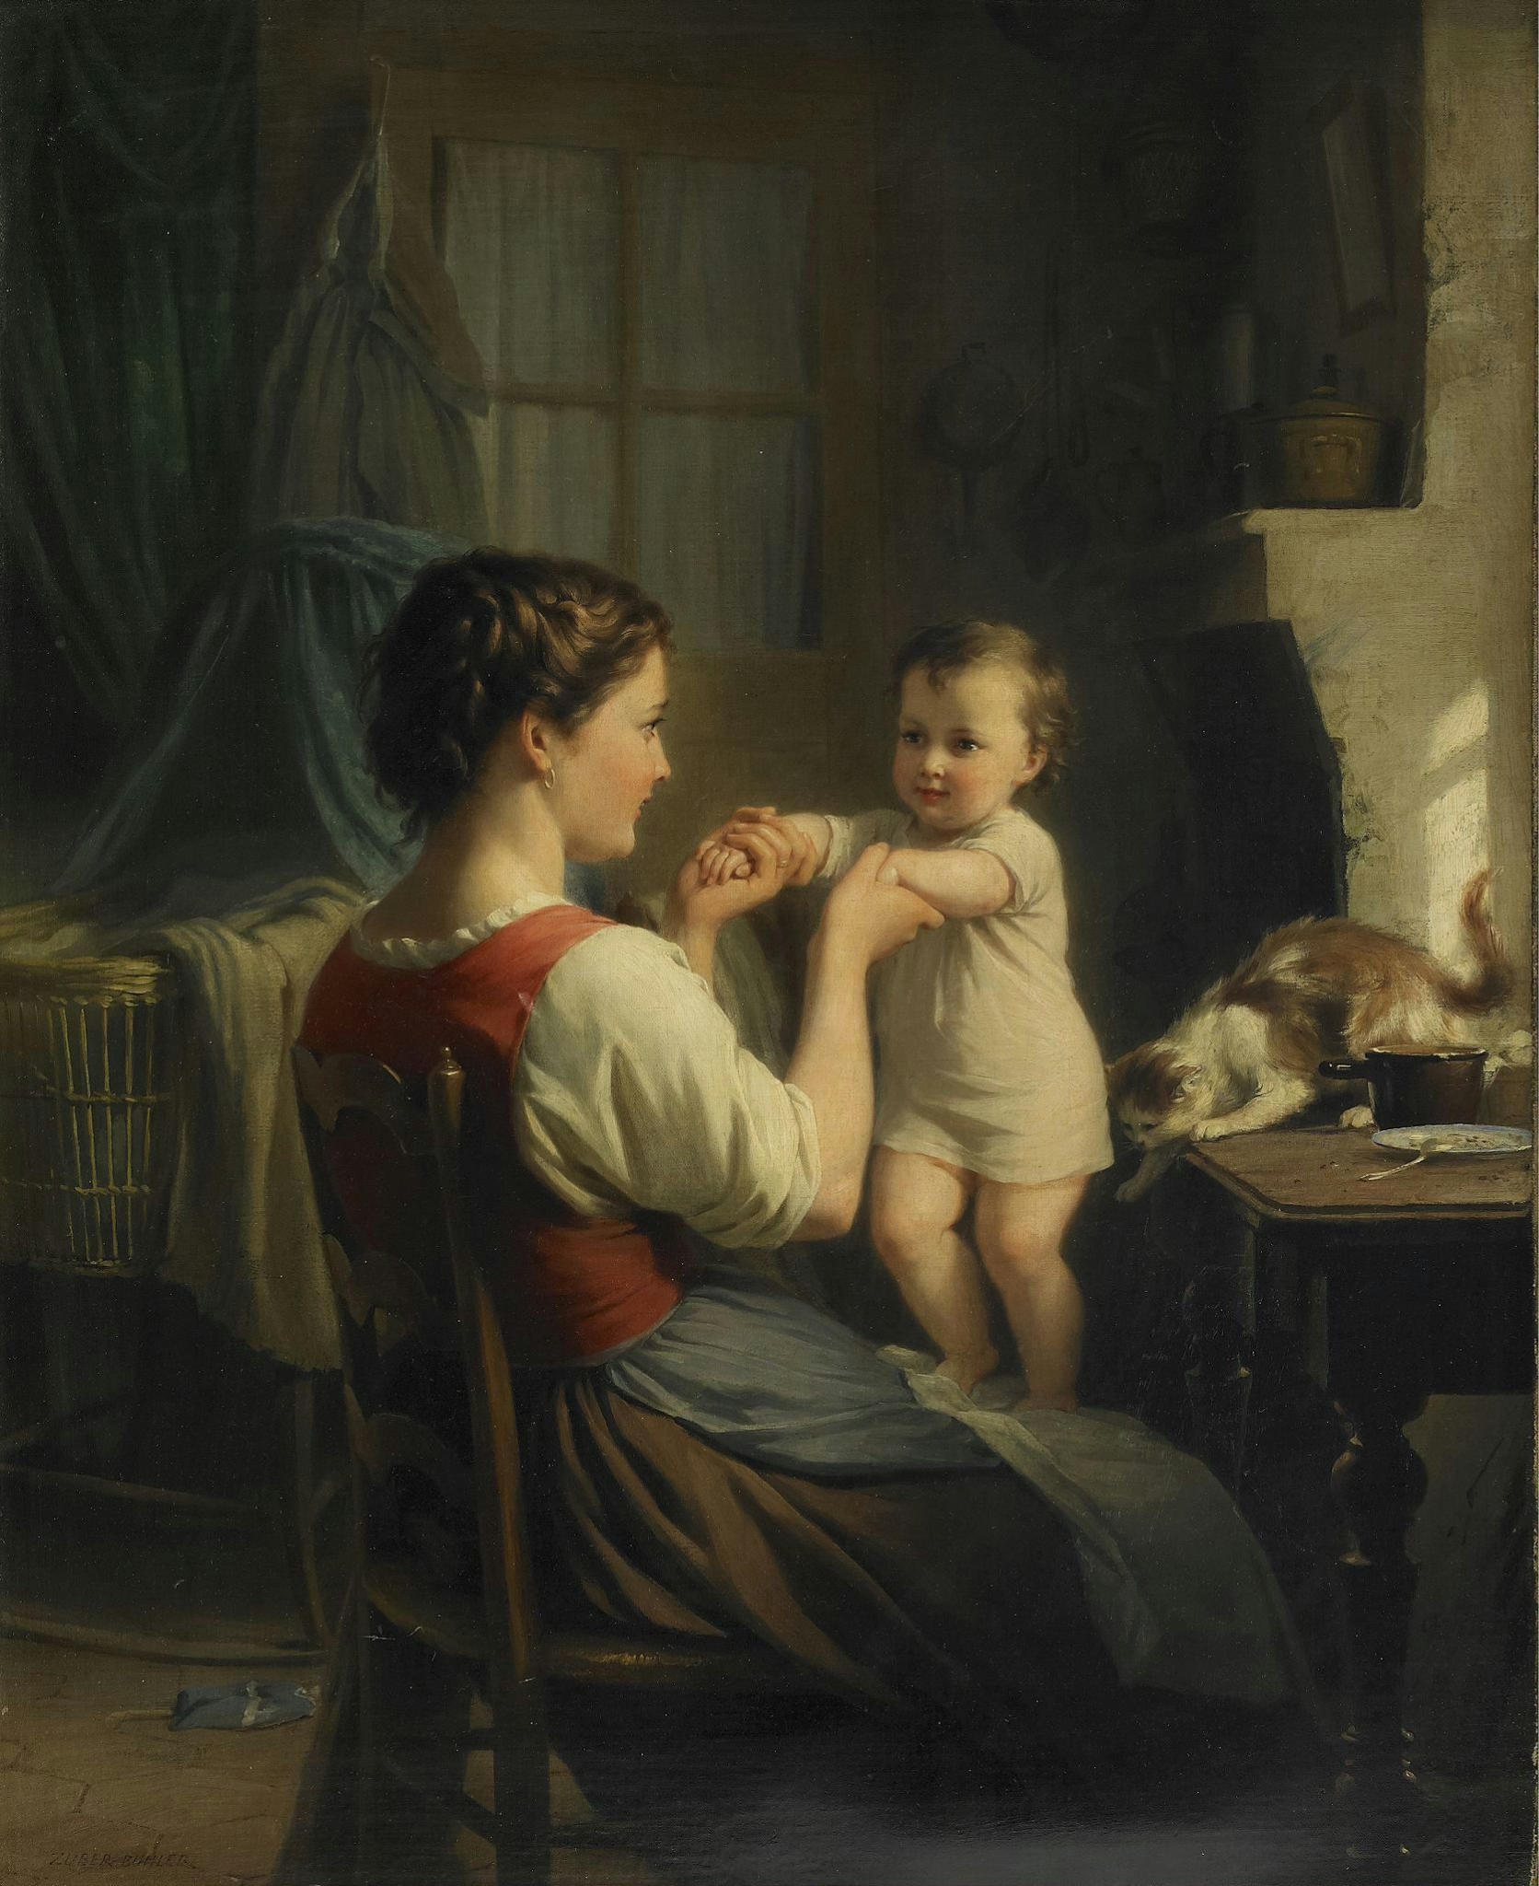

# What did the first mother do to the speaker?

**Ans.** The first mother carried the speaker, gave birth to her, nurtured her, and set a good example for her to follow in life. She played a crucial role in shaping the speaker’s personality and career.

# Who was the speaker’s second mother? Describe her briefly.

**Ans.** The speaker’s second mother was actually the same woman—her real mother—but in old age. With time, her mind weakened, and she became like a child who needed care. Though she looked the same on the outside, she had changed internally, becoming dependent on the speaker.

# What is the speaker’s advice to her own children?

**Ans.** The speaker advises her children to love and care for their mother at every stage of life—whether she is strong and guiding them or weak and dependent on them—just as their mother loved them.

# Cohesive Sentences

Cohesive sentences are sentences that are logically connected and flow smoothly. They help maintain clarity and coherence in writing by using cohesive devices such as:

* **Conjunctions** (and, but, or, because, so)
* **Pronouns** (he, she, it, they, this, that)
* **Transitional words** (however, therefore, moreover, meanwhile)
* **Repetition of key ideas** (using synonyms or rephrasing)

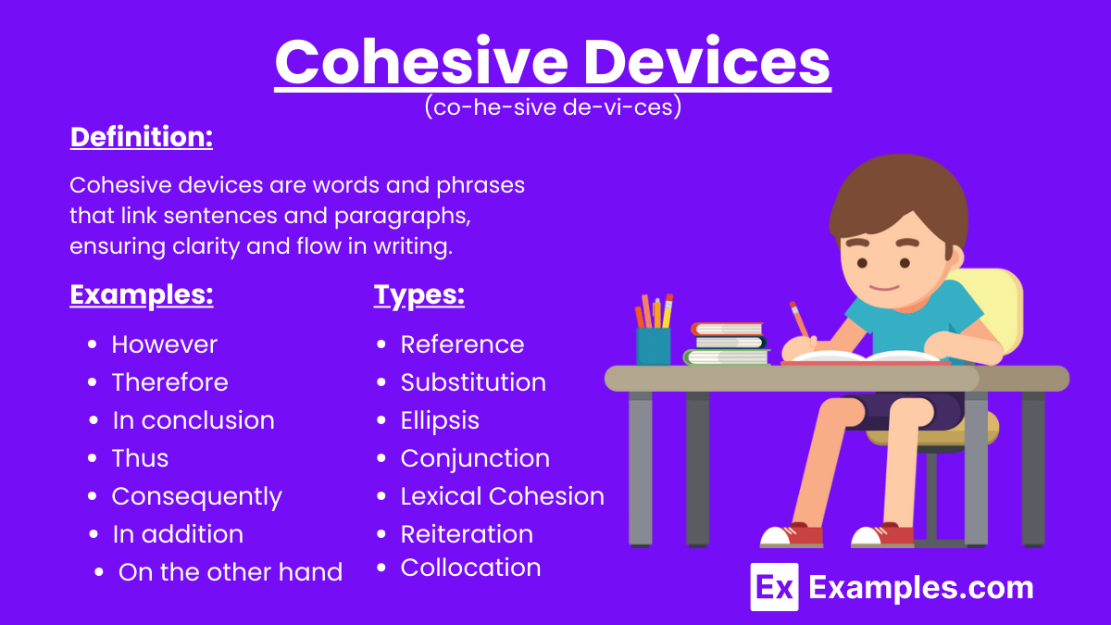

These devices ensure ideas connect meaningfully and make writing easier to follow.

***Read more here: (***[***https://www.ieltsadvantage.com/2015/08/12/cohesive-devices/***](https://www.ieltsadvantage.com/2015/08/12/cohesive-devices/)***)***

# Answers to the Exercises

**Part A: Fill in the blanks using cohesive devices**

**Part A: Fill in the blanks using AND, SO, BECAUSE, BUT or OR.**

1. I could not go out last night _____ I was too busy.

2. I could not go with my friend ________ he went without me.

3. My friend went to the cinema to see a film ______ the film wasn't very good.

4. The cinema was full of people _________ they were all smoking.

5. I like people ____ don't like smoke.

**Ans.**

1. I could not go out last night **because** I was too busy.
2. I could not go with my friend, **so** he went without me.
3. My friend went to the cinema to see a film, **but** the film wasn’t very good.
4. The cinema was full of people, **and** they were all smoking.
5. I like people **but** I don’t like smoke.

# Part B: Combine the sentences using cohesive devices.

1. Ali is an only child. He is very independent.

2. You have to bring your examination card. You cannot join the exam without the examination card.

3. She went to work. She didn't want to go.

4. My cat was hungry. It had not eaten since breakfast that day.

5. A book can be a lot of fun. A book can be boring.

**Ans.**

1. Ali is an only child, **so** he is very independent.
2. You have to bring your examination card, **or** you cannot join the exam.
3. She went to work, **but** she didn’t want to go.
4. My cat was hungry **because** it had not eaten since breakfast.
5. A book can be a lot of fun, **but** it can also be boring.

# Part C: Combining sentences in the paragraph

The Garuda team was three games down. The Garuda team had to win the next four games to move to the next round. Fans of Garuda were worried. Garuda had not won any championship for four years. No team had ever come back in the playoffs from a three-game deficit.All of the Garuda fans knew this. The fans of the Garuda watched anxiously as the fourth game against the Bear began. The fans of the Bear watched confidently. The Bears had a good chance to win the match. The Garuda fans still had hope.

**Ans.** The Garuda team was three games down, **so** they had to win the next four games to move to the next round. Fans of Garuda were worried **because** Garuda had not won any championship for four years. No team had ever come back in the playoffs from a three-game deficit, **but** all of the Garuda fans knew this. The fans of the Garuda watched anxiously as the fourth game against the Bear began, **while** the Bear’s fans watched confidently. The Bears had a good chance to win the match, **but** the Garuda fans still had hope.



